AI Assisted coding Assignment – 13.4
Name:Kanneboyina Meghana
Batch-44
HTNO:2303a52345
Task 1: Refactoring Data Transformation Logic
Prompt: Refactor the Python code that doubles values in a list using a loop into a more Pythonic approach."
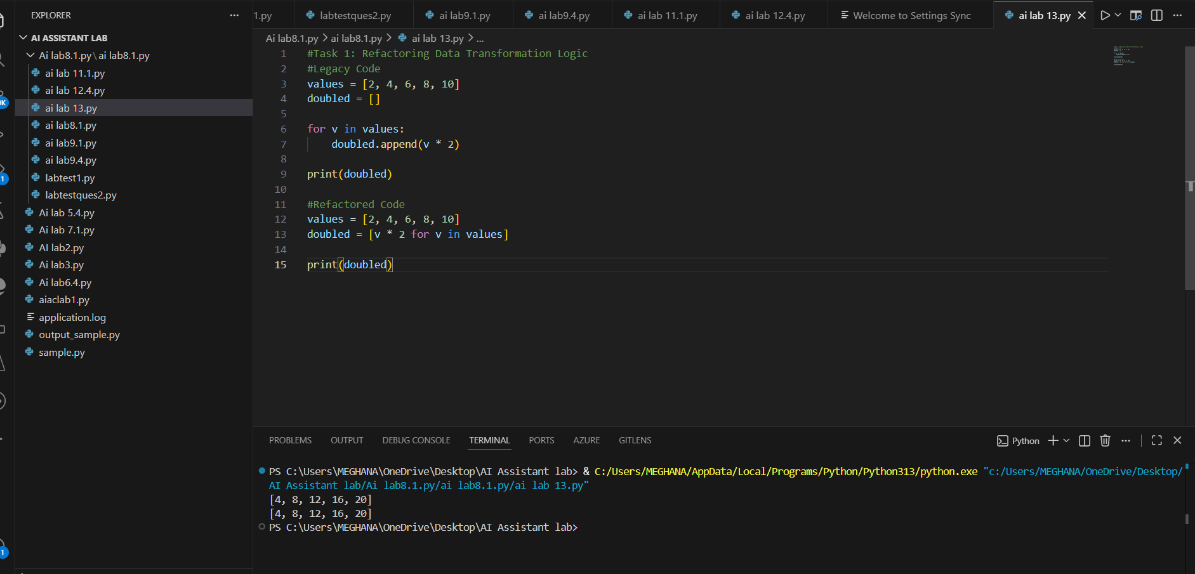
Explanation:
The loop was replaced with a list comprehension, which is shorter and more Pythonic.
List comprehensions improve readability and performance.
Task 2: Improving Text Processing Code Readability
Prompt :"Suggest a more efficient way to concatenate words in a list into a sentence."
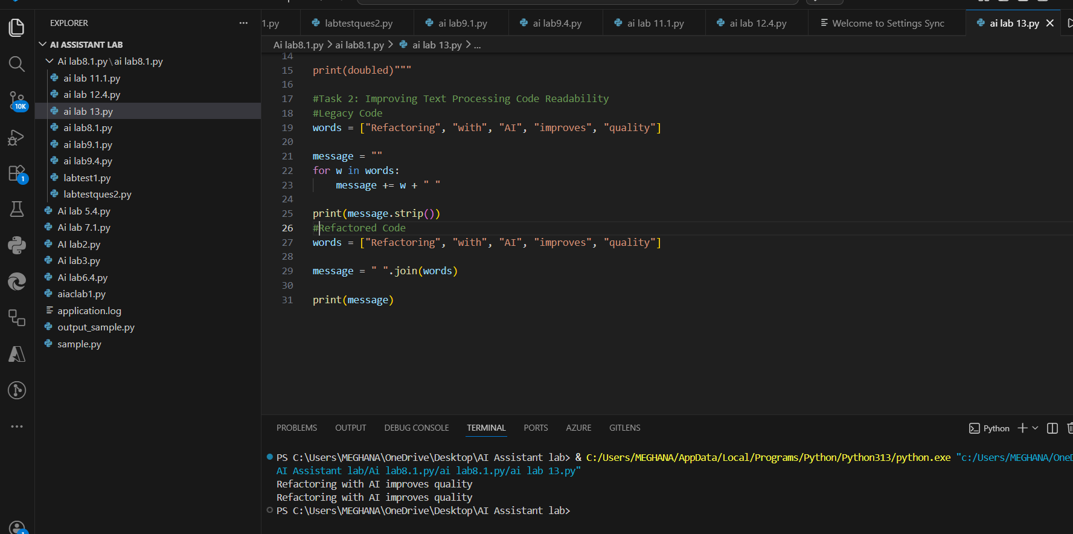
Explanation
*The join() method is used to combine list elements into a single string.
*It is more efficient and readable than repeated string concatenation.

Task 3: Safer Access to Configuration Data
Prompt:"Refactor dictionary key access using safer Python methods."
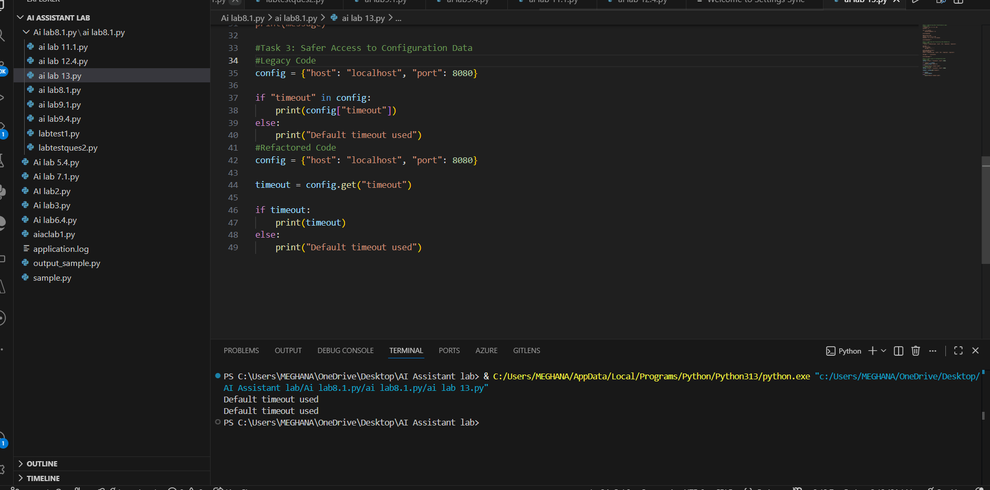
Explanation
The get() method safely retrieves dictionary values without causing errors if the key does not exist.
Task 4: Refactoring Conditional Logic for Scalability
Prompt :"Refactor multiple if-elif conditions for arithmetic operations using a mapping technique."
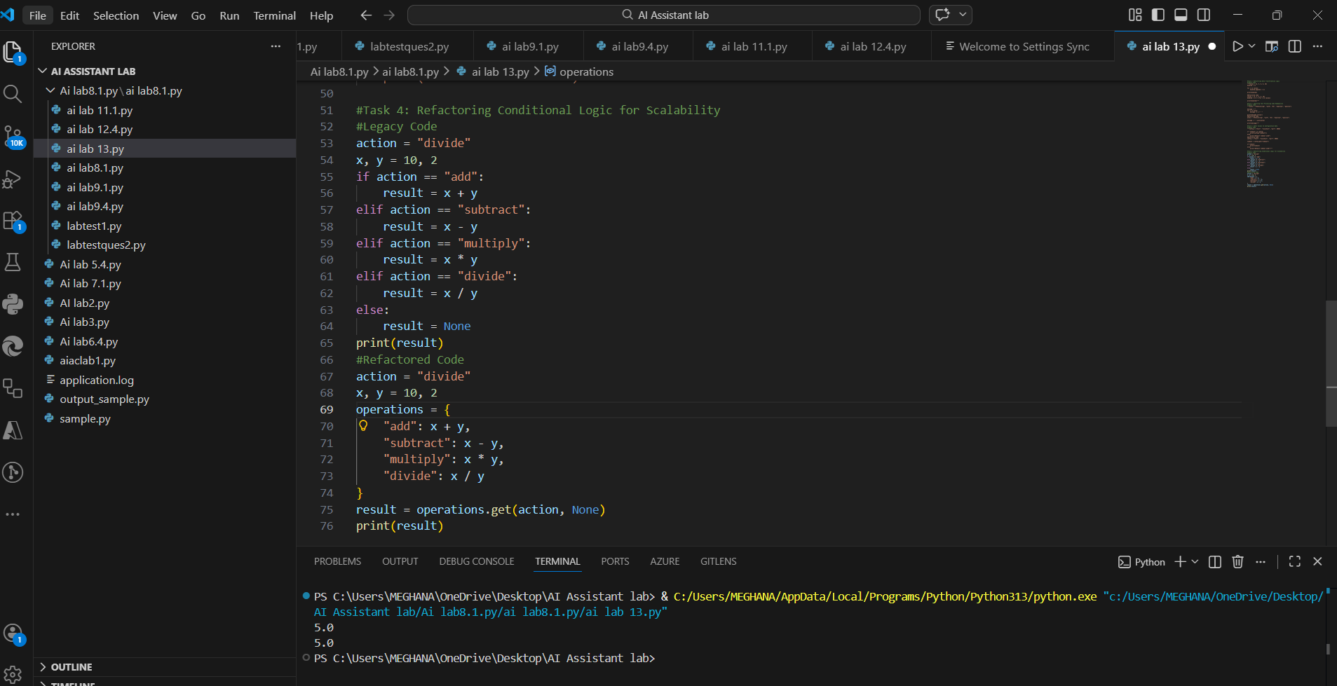
Explanation
A dictionary mapping technique replaces multiple conditional statements.
This makes the code cleaner, scalable, and easier to maintain.
Task 5: Simplifying Search Logic in Collections
Prompt:"Refactor code that searches for an item in a list using a simpler Python method."
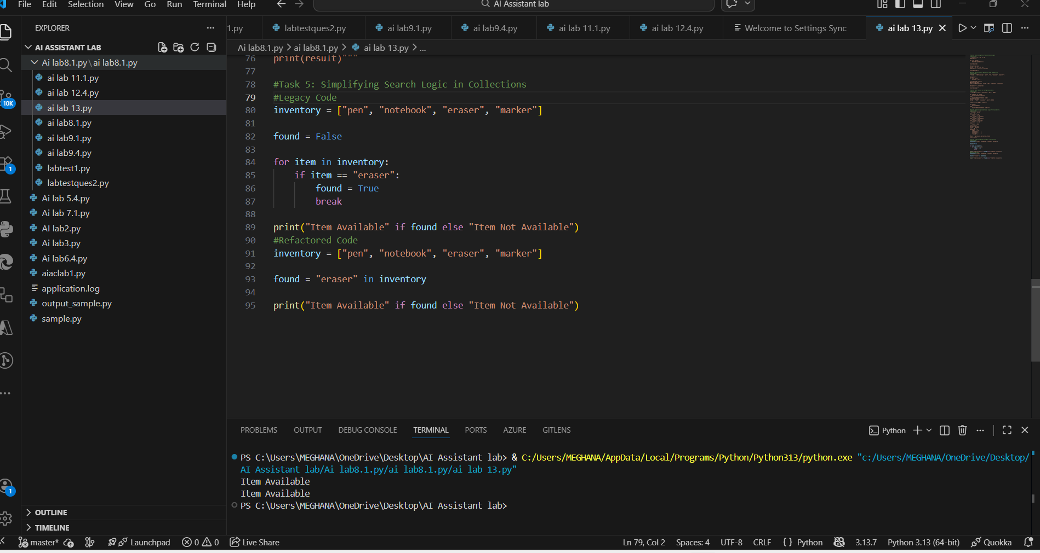
Explanation
The in operator directly checks if an element exists in a list.
This eliminates the need for a manual loop and improves readability.

